Nama : Tsaniya Faridah Maulida
Nim : 211331031
Kelas : 1A- TTE
Elektronika Analog
LATIHAN SOAL BAB 3 No. 1 – 39
- What names are applied to the two types of BJT transistors? Sketch the basic construction of each and label the various minority and majority carriers in each. Draw the graphic symbol next to each. Is any of this information altered by changing from a silicon to a germanium base?
Jawaban
Kedua jenis Bipolar Junction Transistor (BITS) adalah,
•Transistor PNP
•Transistor NPN Pada transistor PNP, semikonduktor tipe-n ditempatkan di antara dua semikonduktor tipe-p pada transistor NPN, semikonduktor tipe-p ditempatkan di antara dua semikonduktor tipe n
- What is the major difference between a bipolar and a unipolar device?
Jawaban
Perbedaan utama antara transistor bipolar dan unbipolar ialah transistor bipolar memanfaatkan elektron dan lubang dalam proses injeksi atau proses muatan yang terdiri dari dua jenis transistor serta perubahan listriknya dalam jumlah kecil dapat menghasilkan perubahan arus listrik jumlah besar pada terminal kolektor. Sedangkan transistor unbipolar hanya memanfaatkan salah satunya dari elektron atau lubang dalam proses muatan.
- How must the two transistor junctions be biased for proper transistor amplifier operation?
Jawaban
Bias mundur dan bias maju
- What is the source of the leakage current in a transistor?
Jawaban
Sumber arus bocor (Io) pada transistor ialah arus pembawa minoritas di kolektor
- Sketch a figure similar to Fig. 3.3 for the forward-biased junction of an npn transistor. Describe the resulting carrier motion.
Jawaban:
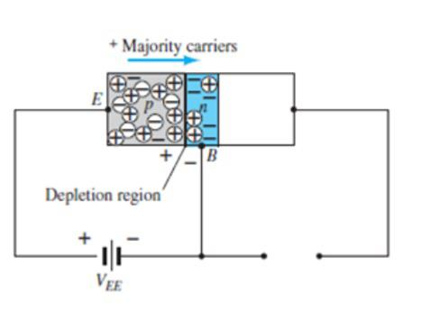
- Sketch a figure similar to Fig. 3.4 for the reverse-biased junction of an npn transistor. Describe the resulting carrier motion.
Jawaban:
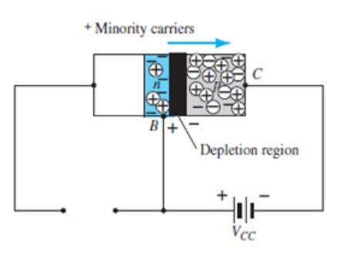
- Sketch a figure similar to Fig. 3.5 for the majority- and minority-carrier flow of an npn transistor. Describe the resulting carrier motion.
Jawaban
- Which of the transistor currents is always the largest? Which is always the smallest? Which two currents are relatively close in magnitude?
Jawaban
I_{E} terbesar
I_{B} terkecil
I_{C} $≅$ I_{E}
- If the emitter current of a transistor is 8 mA and I_{B} is 1/100 of I_{C} , determine the levels of I_{C} and I_{B}.
Jawaban
I_{B} = $\frac{1}{100}Ic→Ic=100I_{B}$
$$I_{E}=I_{C}+I_{B}=100I_{B}+I_{B}=1O1I_{B}$$
$$I_{B}= \frac{IE}{101}=\frac{8 mA}{101}=7.921µA$$

$$I_{C}=100I_{B}=100 \left(79,21 µA\right)=7,921 mA$$
- From memory, sketch the transistor symbol for a pnp and an npn transistor, and then insert the conventional flow direction for each current
Jawaban
- Using the characteristics of Fig. 3.7 , determine V_{BE} at I_{E} 5 mA for V_{CB} = 1,10, and 20 V. Is it reasonable to assume on an approximate basis that V _{CB} has only a slight effect on the relationship between V_{BE} and I_{E} ?
Jawaban
$$I_{E}=5mA, V_{CB}=1V ; V_{BE}=800mV$$
$$V_{CB}=10 V ;V_{BE}=770 mV$$
$$V_{CB}=20 V ; V_{BE}=750 mV$$
Perubahan dari Vcb ialah 20 volt : 1 volt = 20 : 1
- a. Determine the average ac resistance for the characteristics of Fig. 3.10b .
b. For networks in which the magnitude of the resistive elements is typically in kilohms, is the approximation of Fig. 3.10c a valid one [based on the results of part (a)]?
Jawaban
- $r_{av}=\frac{∆V}{∆I}=\frac{0,9 V-0,7 V}{8 mA-0}=25 Ω$
- Ya, karena nilai resistansi dari 25 $Ω$ diabaikan dibanding dengan nilai resistansi lainnya
- a. Using the characteristics of Fig. 3.8 , determine the resulting collector current if I_{E =} 4.5 mA and V_{CB} = 4 V.
b. Repeat part (a) for I_{E} 4.5 mA and V_{CB} 16 V.
c. How have the changes in V_{CB} affected the resulting level of I_{C} ?
d. On an approximate basis, how are I_{E} and I_{C} related based on the results above?
Jawaban
- $I_{C}≅I_{E}=4,5 mA$
- $I_{C}≅I_{E}=4,5 mA$
- Perubahan Vcb yang mempengaruhi tingkat Ic, diabaikan karena perubahan tersebut tidak dapat dideteksi pada rangkaian ini
- $I_{C}≅I_{E}$
- a. Using the characteristics of Figs. 3.7 and 3.8 , determine I_{C} if V_{CB} = 10 V and V _{BE} = 800mV.
b. Determine V_{BE} if I_{C} = 5 mA and V_{CB} = 10 V.
c. Repeat part (b) using the characteristics of Fig. 3.10b .
d. Repeat part (b) using the characteristics of Fig. 3.10c .
e. Compare the solutions for V_{BE} for parts (b) through (d). Can the difference be ignored if voltage levels greater than a few volts are typically encountered?
Jawaban
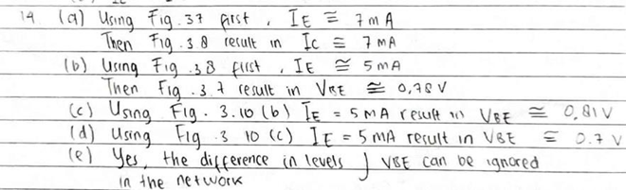
- a. Given an α_{dc} of 0.998, determine I_{C} if I_{E} = 4 mA.
b. Determine α_{dc} if I_{E} = 2,8 mA and I_{B} = 20 µA
c. Find I_{E} if I_{B} = 40 µA and is 0,98.
Jawaban
- $I_{C}$ = α $I_{E}$= (0.998)(4 mA) = 3.992 Ma

- From memory only, sketch the common-base BJT transistor configuration (for npn and pnp ) and indicate the polarity of the applied bias and resulting current directions.
Jawaban
- Calculate the voltage gain (A_{v} = V_{L}/V_{i}) for the network of Fig. 3.12 if Vi = 500 mV and R = 1 kΩ. (The other circuit values remain the same.)
Jawaban
Ii = $\frac{V1}{R1}$ = $500\frac{MV}{20Ω}$ = 25 mA

I2 = I1=25 mA
V2 = I1 R1
= (25 Ma)(1KΩ)
= 25 V
Ao = $\frac{Vo}{V1}$ = $\frac{25 v}{0,5v}$ = 50
- Calculate the voltage gain (A_{v} = V_{L}/V_{i}) for the network of Fig. 3.12 if the source has an internal resistance of 100 Ω in series with Vi.
Jawaban
Ii = $\frac{Vi}{R1+R3}$ = $\frac{200 mV}{20Ω+100Ω}$ = $\frac{200 mV}{120Ω}$ = 1,67 mA
I2 = Ii =1,67 mA
V2 = I.R = (1,67 mA)(5KΩ) = 35 V
Av = $\frac{Vo}{Io}$ = $\frac{0,35 V}{O,2 V}$ = 41,75

- Define I_{CBO} and I_{CEO} . How are they different? How are they related? Are they typically close in magnitude?
- Using the characteristics of Fig 3.14:
(a) Find the value of IC corresponding to VBE = +750 mV and VCE = +5 V
IB = 35µA, IC = 5,2 mA
(b) Find the value of VCE and VBE corresponding to IC = 3 mA and IB = 30 µA.
VCE = 13 V, VBE = 0.75 V
- (a) For the common-emitter characteristics of Fig. 3.14, find the dc beta at an operating point
of VCE = +8 V and IC = 2 mA
ßdc = $\frac{Ic}{IB}$ =$\frac{2 mA}{18µA}$ = 111.11
(b) Find the value of α corresponding to this operating point.
α = $\frac{ß}{ß+1}$ = $\frac{111.11}{111.11+1}$ = 0.991
(c) Calculate the approximate value of ICBO using the dc beta value obtained in part (a).
ICBO = ( 1 – α ) ICEO = ( 1 – 0.991) (0.3 mA) = 27 µA
- (a) Using the characteristics of Fig. 3.14a, determine ICEO at VCE = 10 V.
ICEO = 0.3 mA
(b) Determine ßdc at IB = 10 µA and VCE = 10 V
IC = 1.35 mA
ßdc = $\frac{Ic}{IB}$ = $\frac{1.35 mA}{10 µA}$ = 135
(c) Using the ßdc determined in part (b), calculate ICBO.
α = $\frac{ß}{ß+1}$ = $\frac{135}{136}$ = 0.9926
ICBO = (1-α) ICEO
= (1-0.9926)(0.3mA) = 2.2 µA
- (a) Using the characteristics of Fig. 3.14a, determine ßdc at IB = 80 µA and VCE = 5 V
ßdc = $\frac{Ic}{IB}$ = $\frac{6.85 mA}{80 µA}$ = 85,6
(b) Repeat part (a) at IB = 5 µA and VCE = 15 V
ßdc = $\frac{Ic}{IB}$ = $\frac{1 mA}{5 µA}$ = 2
(c) Repeat part (a) at IB = 30 µA and VCE = 10 V
ßdc = $\frac{Ic}{IB}$ = $\frac{3.35 mA}{30 µA}$ = 111,6
(d) Reviewing the results of parts (a) through (c), does the value of ßdc change from point to
point on the characteristics? Where were the higher values found? Can you develop any general conclusions about the value of ßdc on a set of characteristics such as those provided in Fig. 3.14a
level tertinggi pada nilai Ic
- (a) Using the characteristics of Fig. 3.14a, determine ßac at IB = 80 µA and VCE = 5 V
ßac = $\frac{∆Ic}{∆IB}$ = $\frac{7.5 mA- 6.2 mA}{90 µA-70 µA}$ = 65
(b) Repeat part (a) at IB = 5 µA and VCE = 15 V
ßac = $\frac{∆Ic}{∆IB}$ = $\frac{1.2 mA- 0.4 mA}{10 µA - 0 µA}$ = 80
(c) Repat part (a) at IB = 30 µA and VCE = 10 V
ßac = $\frac{∆Ic}{∆IB}$ = $\frac{4.2 mA- 2.3 mA}{40 µA - 20 µA}$ = 95
(d) Reviewing the results of parts (a) through (c), does the value of ßac change from point to point on the characteristics? Where are the high values located? Can you develop any general conclusions about the value of ßac on a set of collector characteristic ?
nilai tertinggi terdapat pada Ic
(e) The chosen points in this exercise are the same as those employed in Problem 23. If Problem 23 was performed, compare the levels of ßdc and ßac for each point and comment on the trend in magnitude for each quantity
ßdc > ßac
- Using the characteristics of Fig. 3.14a, determine ßdc at IB = 25 µA and VCE = 10 V. Then calculate αdc and the resulting level of IE. (Use the level of IC determined by IC = ßdc IB)
ßdc = $\frac{Ic}{IB}$ = $\frac{2.9 mA}{25 µA}$ = 116
α = $\frac{ß}{ß+1}$ = $\frac{116}{116+1}$ = 0.991
IE = $\frac{Ic}{α}$ = $\frac{2.9 mA}{0.991}$ = 2.93 mA
- (a) Given that αdc = 0.987, determine the corresponding value of ßdc
ß = $\frac{α}{1- α}$ = $\frac{0.987}{1-0.987}$ = 75,92
(b) Given ßdc = 120, determine the corresponding value of α
α = $\frac{ß}{ß+ 1}$ = $\frac{120}{120+1}$ = 0.992
(c) Given that ßdc = 180 and IC = 2.0 mA, find I IE and IB.
IB = $\frac{Ic}{ß}$ = $\frac{2 mA}{180}$ = 11.11µA
IE = IC + IB = 2 mA + 11.11 µA = 2.011 mA
- From memory, and memory only, sketch the common-emitter configuration (for npn and pnp) and insert the proper biasing arrangement with the resulting current directions for IB, IC + IE.
- 2An input voltage of 2 V rms (measured from base to ground) is applied to the circuit of Fig.3.21. Assuming that the emitter voltage follows the base voltage exactly and that Vbe (rms) = 0.1 V, calculate the circuit voltage amplification (Av = Vo /Vi) and emitter current for RE = 1 kΩ.
Ve = Vi – Vbe = 2 V – 0.1 V = 1.9 V
Av = $\frac{Vo}{Vi}$ = $\frac{1.9 V}{2 V}$ = 0.95 = 1
Ie = $\frac{Ve}{Re}$ = $\frac{1.9 V}{1 KΩ}$ = 1.9 mA
- For a transistor having the characteristics of Fig. 3.14, sketch the input and output characteristics of the common-collector configuration.
karakteristik output :
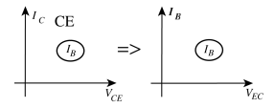
Karakteristik input :
Common-emitter input dapat digunakan secara lansung untuk perhitungan common-collector
- Determine the region of operation for a transistor having the characteristics of Fig. 3.14 if
ICmax = 7 mA, VCEmax = 17 V, and PCmax = 40 mW
PCmax = 40 mW = VCEIC
IC = ICmax, VCE = $\frac{PCmax}{ICmax}$ = $\frac{40 mW}{7 mA}$ = 5.71 V
VCE = VCEmax, IC = $\frac{PCmax}{VCEmax}$ = $\frac{40 mW}{17 V}$ = 2.35 mA
VCE = V, IC = $\frac{PCmax}{VCE}$ = $\frac{40 mW}{ V}$ = mA
IC = mA, VCE = $\frac{PCmax}{IC}$ = $\frac{40 mW}{ mA}$ = V
VCE = V, IC = $\frac{PCmax}{VCE}$ = $\frac{40 mW}{ V}$ = mA
- Determine the region of operation for a transistor having the characteristics of Fig. 3.8 if IC_{max} = 6 mA, V_{CB}max = 15 V, and PC_{max} = 30 mW.
IC = ICmax, VCE = $\frac{PCmax}{ICmax}$ = $\frac{30 mW}{6 mA}$ = 5 V
VCB = VCBmax, IC = $\frac{PCmax}{VCBmax}$ = $\frac{30 mW}{15 V}$ = mA
IC = , VCE = $\frac{PCmax}{IC}$ = $\frac{40 mW}{ mA}$ = V
- Referring to Fig. 3.23, determine the temperature range for the device in degrees Fahrenheit
temperature akan beroperasi dalam -55 ͦ C≤ Tj ≤ 150 ͦ C
ͦ F = $\frac{9}{5}$ ͦ C + 32 ͦ
= $\frac{9}{5}$(150 ͦ C) + 32 ͦ = -67 ͦ F
ͦ F = $\frac{9}{5}$ (150 ͦ C) + 32 ͦ = 302 ͦ F . Jadi, -67 ͦ C≤ Tj ≤ 302 ͦ C
- Using the information provided in Fig. 3.23 regarding PDmax, VCEmax, ICmax and VCEsat, sketch the boundaries of operation for the device
ICmax = 200 mA ,VCEmax = 30 V, PDmax = 625 mW
IC = ICmax, VCE = $\frac{PDmax}{ICmax}$ = $\frac{625 mW}{200 mA}$ = 3.125 V
VCE = VCEmax, IC = $\frac{PDmax}{VCEmax}$ = $\frac{625 mW}{30 V}$ = 20.83 Ma
IC = 100 mA , VCE = $\frac{PDmax}{IC}$ = $\frac{625 mW}{ 100 mA}$ = 6.25 V
VCE = 20 V , IC = $\frac{PDmax}{VCE}$ = $\frac{635 mW}{ 20 V}$ = 31.25 mA
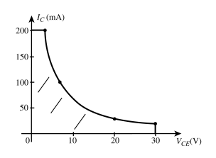
- Based on the data of Fig. 3.23, what is the expected value of ICEO using the average value of ßdc?
ICBO = 50 nA max
ßavg = $\frac{ß\min{+ ßmax}}{2}$ = $\frac{50+150}{ 2}$ = $\frac{200}{ 2}=$100. Jadi, ICEO = ßicbo = (100) (50 nA) = 5µA

- How does the range of hFE (Fig. 3.23(j), normalized from hFE = 100) compare with the range of hFE (Fig. 3.23(f)) for the range of IC from 0.1 to 10 mA?

36. Using the characteristics of Fig. 3.23b, determine whether the input capacitance in the common-base configuration increases or decreases with increasing levels of reverse-bias potential. Can you explain why?
Jawaban
Ketika potensi bias balik meningkat besarnya, kapasitansi input Cibo berkurang (Gbr. 1). 3.23(b)). Peningkatan potensi bias balik menyebabkan lebar daerah penipisan menjadi meningkat, sehingga mengurangi kapasitansi ( ∁ = 𝜀$\frac{A}{d}$ ) .

37. Using the characteristics of Fig. 3.23f, determine how much the level of hfe has changed from its value at 1 mA to its value at 10 mA. Note that the vertical scale is a log scale that may require reference to Section 11.2. Is the change one that should be considered in a design situation?
Jawaban
( b ) Hasil tersebut mengkonfirmasi kesimpulan dari soal 21 dan 22 bahwa beta cenderung meningkat dengan meningkatnya arus kolektor.
38.Using the characteristics of Fig. 3.23j, determine the level of βdc at IC = 10 mA at the three levels of temperature appearing in the figure. Is the change significant for the specified temperature range? Is it an element to be concerned about in the design process?
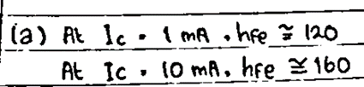

- (a)Using the characteristics of Fig. 3.24, determine ac at IC = 14 mA and VCE = 3 V.
- Determine βdc at IC = 1 mA and VCE = 8 V.
- Determine βac at IC = 14 mA and VCE = 3 V.
- Determine βdc at IC = 1 mA and VCE = 8 V.
- How does the level of βac and βdc compare in each region?
- Is the approximation βdc ≅ βac a valid one for this set of characteristics?

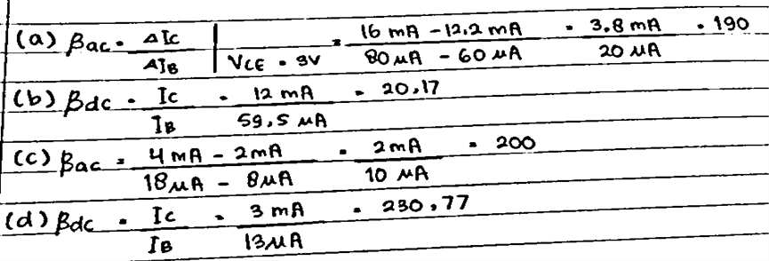

(e) Dalam kedua kasus βdc sedikit lebih tinggi dari βac (≅10%)
(f) (g)
Secara umum βdc danβ ac meningkat dengan meningkatnya IC untuk VCE tetap dan keduanya menurun untuk penurunan tingkat VCE untuk IE tetap. Namun, jika IC meningkat sementara VCE menurun ketika bergerak di antara dua titik pada karakteristik, peluangnya adalah tingkat βdc atau βac mungkin tidak berubah secara signifikan. Dengan kata lain, peningkatan yang diharapkan karena peningkatan arus kolektor dapat diimbangi dengan penurunan VCE. Data di atas mengungkapkan bahwa ini adalah kemungkinan yang kuat karena level β relatif dekat

